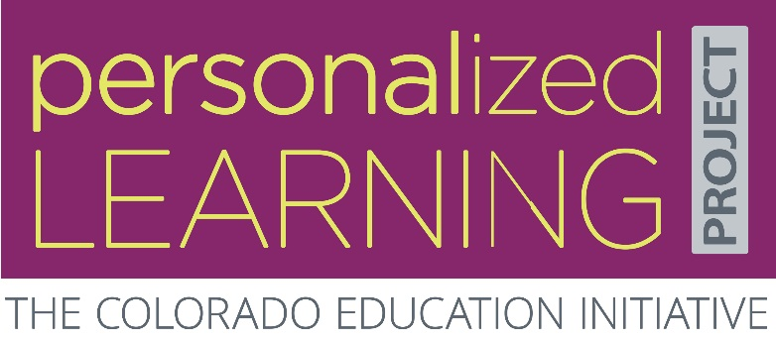
School Name
Aspirations Development Tool
Please use this tool to create an aspiration for your school. Your school aspiration is a student-centered goal for your school to work towards. This will be your North Star and starting point for redesigning your school.

Ideas for School Aspirations
Shared by your team on October 25th in response to this prompt:
“Please share your personal aspirations for your school. What is the student-centered goal your school should work towards?”
CAPTURE FROM GOOGLE FORM

Insights from Empathy-Building
What are the deeper understandings your team uncovered on October 25th?

School Aspiration (First Draft)
Aspirations are most powerful when they are built from the needs of your school community. Once you draft an aspiration, gather feedback, and continue to fine tune your ideas. Clarify your ideas as much as possible, but don’t feel a need to perfect or edit your language.
Criteria for a good aspiration:
- It’s student-centered. Reading through your aspiration, it should be clear what impact you’d like to have on the student experience. (What about shaping adult culture? What about creating structures? These might be activities you do…but the aspiration should focus on students.)
- It’s about the “Why,” not the “How.” Your aspiration shouldn’t be a specific solution, but a vision/mission that could lead to many different solutions.
- It’s not too broad (create world peace) or too small (repaint the school entrance). Does this aspiration point to specific behaviors? If you shared it with people at your school, would they immediately know what you’re talking about?
- It’s positive. Your aspiration should be framed as a positive hope to work toward, and not a problem to address.
You can use this sentence stem to get started:
Students will [action-based goals for students], in order to [connection to Deeper Learning competencies].

