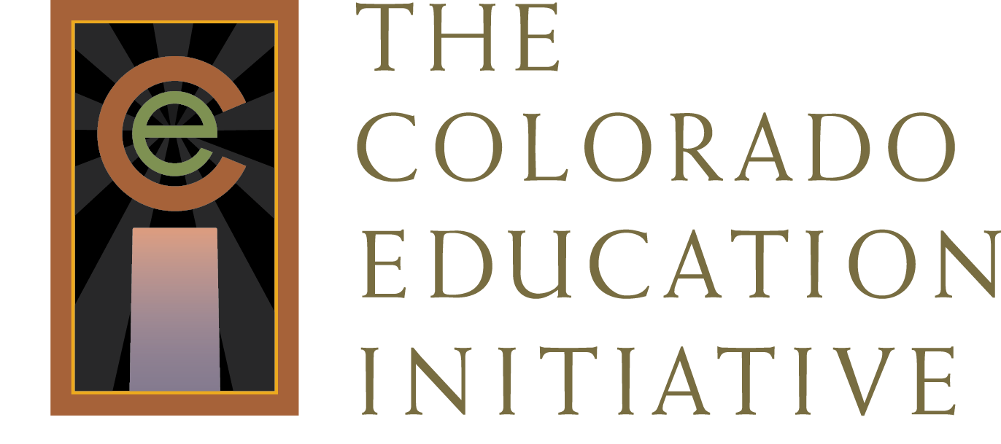
Resource/Program Summary for The Great Body Shop
Overview/Description of Curriculum
THE GREAT BODY SHOP (GBS) contains both a comprehensive health education curriculum for Pre-K through Middle School and a coordinated school health planning tool. The goals of the program are to foster the wellness of children and their families and to support efforts to create a healthy school environment. Using the GBS Teacher’s Guide, monthly Student Issues, and Parent Bulletins, the curriculum builds health knowledge, attitudes, life skills, and critical thinking skills. Using the GBS Coordinated School Health Kit, a school health advisory committee has the tools needed to create a healthy environment, encourage staff wellness, increase parent involvement, promote physical activity/nutrition, and coordinate school-based health services for children. The GBS Coordinated School Health Kit is based on the Centers for Disease Control and Prevention’s (CDC) Eight Component Model. The GBS health curriculum meets National Standards for Health Education, is skills-based, and is consistent with the recommendations of the USDA for nutrition education, the CDC for tobacco prevention, AAHPERD for physical activity/health education, and the National PTA’s Standards for Parental Involvement.

Program Components
- Comprehensive substance abuse and violence prevention embedded in the health curriculum.
- Ten monthly themes which are taught through 40 lessons; each lesson includes performance objectives that develop knowledge, values, life skills, and critical thinking skills.
- Monthly Student Issues and Parent Bulletins are used as a core component to guide student learning.

Program Basics
Grade Level | Lesson Length | Booster Lessons | Teaching Strategies | Cost/Contact
Pre-K through Middle School | 40 lessons per grade level | Additional reinforcement activities provided. | - Supports differentiation of instruction  - Employs multiple modalities for teaching  - Supports cross-content teaching through additional activities  - Engages parents with a Parent Bulletin and through parent-student activities  - Offers monthly student reading issues  - Provides performance assessments | Teacher’s Guide (each grade level, from Pre-K through Middle School): $45.00  Student Issues:  - Grade Pre-K: $6.50 per student per year  - Grades K–6: $5.50 per student per year  - Middle School: $5.50 per student per year  http://www.thegreatbodyshop.net/

Research Base/Results/ Recognition
- Promising Program: The Substance Abuse and Mental Health Services Administration
- Promising Program: Office of Juvenile Justice and Delinquency
- Promising Program: Centers for the Application of Prevention Technologies (CAPT)
- CASEL Select Program: Collaborative for Academic, Social, Emotional Learning, Rating: Excellent
- Action For Healthy Kids: Score: 292/300
- Research-based Program Matrix: Rutgers Safe and Drug Free Schools and Communities Project

Program Standards Alignment
Prepared Graduate Competencies
 | Grade Level
 | PK | K | 1 | 2 | 3 | 4 | 5 | 6 | 7 | 8
Healthy Eating | NA | 1 | 1 | 2 | 2 | 1 | 1 | 2 | 2 | NA
Sexual Health | NA | NA | NA | NA | NA | NA | 1 | 2 | 2 | 2
Health Promotion | 1 | 1 | 2 | 2 | NA | 2 | 2 | 2 | NA | 2
Emotional and Social Wellness | NA | 1 | 1 | 2 | 1 | 2 | 1 | 2 | 1 | 1
Alcohol, Tobacco, and Other Drug Prevention | NA | 1 | NA | 2 | 2 | 2 | 2 | 2 | 2 | 2
Violence Prevention | NA | 1 | 1 | 2 | 1 | 2 | 2 | 1 | NA | 2
Safety | 1 | 1 | 1 | 1 | 1 | 2 | 1 | 1 | 2 | 2

Program Standards Alignment key:

- Completely addresses Grade Level Expectations to mastery
- GLE is addressed with minor adaptations
- GLE is addressed with significant adaptations
- The GLE is not addressed

To fully address the health education standards, additional optional reinforcement activities need to be taught.

See alignment matrix at http://coloradoedinitiative.org/our-work/health-and-wellness/chpe .

Summary
The Great Body Shop is a comprehensive health education curriculum that, with minor adaptations, addresses the Colorado Comprehensive Health Education Standards. It is important to realize that certain optional reinforcement activities need to be added to the required monthly lessons to thoroughly address the standards. This will require additional teaching time beyond the regular provided lessons. The curriculum provides teachers with a wide variety of resources and materials for cross-curricular activities to engage students. The curriculum has an active parent engagement component through newsletters and parent-student activities. The curriculum has recently been updated to address the Colorado Comprehensive Health Education Standards and recent nutritional guidelines. The curriculum requires student issues to be purchased yearly.

