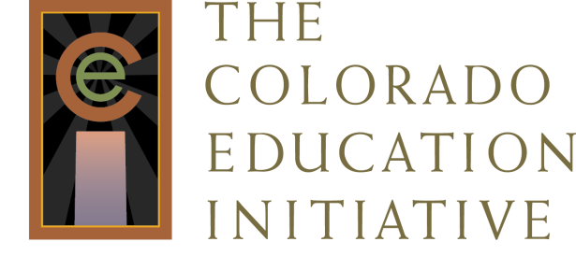

Colorado LDC Consultants

Barb Conroy
(720) 335-0509
barbconroy@msn.com

Terry Dunn
(303) 345-5890
terryanndunn@yahoo.com

Mary Rubadeau
(970) 708-9488
mrubadeau@gmail.com

Gayle Westerberg
(970) 389-7364
gtmmb@msn.com

