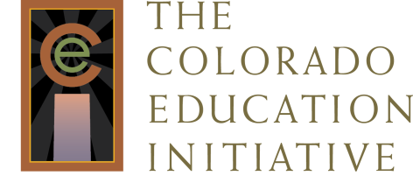

CO Districts with Trained LDC Teachers
Contact Information for LDC District Lead
(As of August 2013)

Denver Public Schools
Savinay Chandrasekhar
savinay_chandrasekhar@dpsk12.org

Thompson School District
Tiffany Utoft
tiffany.brown-utoft@thompsonschools.org

Centennial School District
Curtis Garcia
cgarcia@centennialschool.net

Eagle County School District
Traci Wodlinger
traci.wodlinger@eagleschools.net

Heather Eberts
heather.eberts@eagleschools.net

The Districts of the San Juan BOCES (Dove Creek, Dolores, Cortez, Mancos, Silverton, Durango, Bayfield, Ignacio, Archuleta)

Steve Otter
sotter@sjboces.org

Other Colorado Districts and BOCES That Have Received LDC Training

Platte Canyon
Harrison
Campo
Ouray
Pritchett
Salida
Mountain BOCES
Northeast BOCES
San Luis Valley BOCES
Moffat
Chaffee County
West End Re 2
Wyatt Edison Charter School
North Conejos
South Conejos
Sargeant
Del Norte
Center
Sangre de Cristo

