PARCC Assessment Item & Task Prototype:
10th-Grade ELA Summative Assessment Task

The following screenshots detail a 10th-grade English Language Arts summative assessment item and task prototype released recently by the Partnership for Assessment of Readiness for College and Careers (PARCC). The purpose of the prototype items is to demonstrate to practitioners and policymakers how the assessment items will be aligned with the CCSS and what the student interface of the forthcoming computer-based assessments might look like. This literary analysis and narrative writing task, as well as other prototype items, can be found on the PARCC website at http://www.parcconline.org/samples/english-language-artsliteracy/grade-10-elaliteracy.

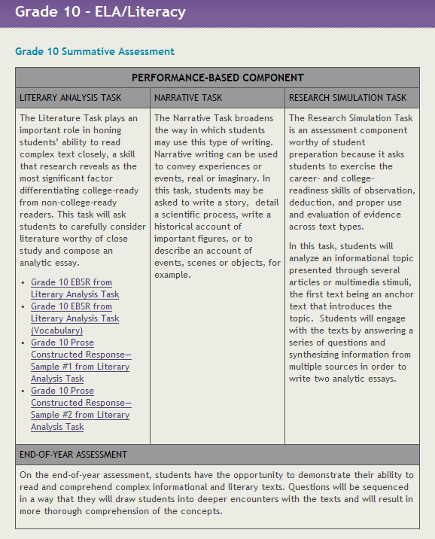
This screenshot details the various elements of this 10th-grade ELA performance task, which includes:
- reading complex grade-level texts;
- extracting evidence from multiple texts;
- literary analysis;
- a focus on the definition and role of academic vocabulary;
- research;
- expository writing; and
- interfacing with active word processing tools.

Readings required for this task:
- Ovid. "Ovid's Metamorphoses: Daedalus and Icarus." Sogang University. Web. 31 Jan. 2012. http://hompi.sogang.ac.kr/anthony/Classics/OvidIcarus.htm
- Sexton, Anne. "To a Friend Whose Work Has Come to Triumph." Hello Poetry. 2009. Web. 31 Jan. 2012. http://hellopoetry.com/poem/to-a-friend-whose-work-has-come-to-triumph/

READING 1: From Ovid's Metamorphoses: “Daedalus and Icarus” (selected excerpt—not the entire piece required for the task)

But Daedalus abhorred the Isle of Crete--
290 and his long exile on that sea-girt shore,
increased the love of his own native place.
"Though Minos blocks escape by sea and land."
He said, "The unconfined skies remain
though Minos may be lord of all the world
295 his sceptre is not regnant of the air,
and by that untried way is our escape."
This said, he turned his mind to arts unknown
and nature unrevealed. He fashioned quills
and feathers in due order -- deftly formed
300 from small to large, as any rustic pipe
prom straws unequal slants. He bound with thread
the middle feathers, and the lower fixed
with pliant wax; till so, in gentle curves
arranged, he bent them to the shape of birds.
305 While he was working, his son Icarus,
with smiling countenance and unaware
of danger to himself, perchance would chase
the feathers, ruffled by the shifting breeze,
or soften with his thumb the yellow wax,
310 and by his playfulness retard the work
his anxious father planned.
But when at last
the father finished it, he poised himself,
and lightly floating in the winnowed air
315 waved his great feathered wings with bird-like ease.
And, likewise he had fashioned for his son
such wings; before they ventured in the air
he said, "My son, I caution you to keep
the middle way, for if your pinions dip
320 too low the waters may impede your flight;
and if they soar too high the sun may scorch them.
Fly midway. Gaze not at the boundless sky,
far Ursa Major and Bootes next.
Nor on Orion with his flashing brand,
325 but follow my safe guidance."
As he spoke
he fitted on his son the plumed wings
with trembling hands, while down his withered cheeks
the tears were falling. Then he gave his son
330 a last kiss, and upon his gliding wings
assumed a careful lead solicitous.

READING 2: Anne Sexton’s "To a Friend Whose Work Has Come to Triumph by Anne Sexton"

To a Friend Whose Work Has Come to Triumph
Consider Icarus, pasting those sticky wings on,
testing that strange little tug at his shoulder blade,
and think of that first flawless moment over the lawn
of the labyrinth. Think of the difference it made!
There below are the trees, as awkward as camels;
and here are the shocked starlings pumping past
and think of innocent Icarus who is doing quite well.
Larger than a sail, over the fog and the blast
of the plushy ocean, he goes. Admire his wings!
Feel the fire at his neck and see how casually
he glances up and is caught, wondrously tunneling
into that hot eye. Who cares that he fell back to the sea?
See him acclaiming the sun and come plunging down
while his sensible daddy goes straight into town.

Student Interface Part 1:

The task is intentionally sequenced, beginning with these two questions that require students to extract relevant evidence from complex text.

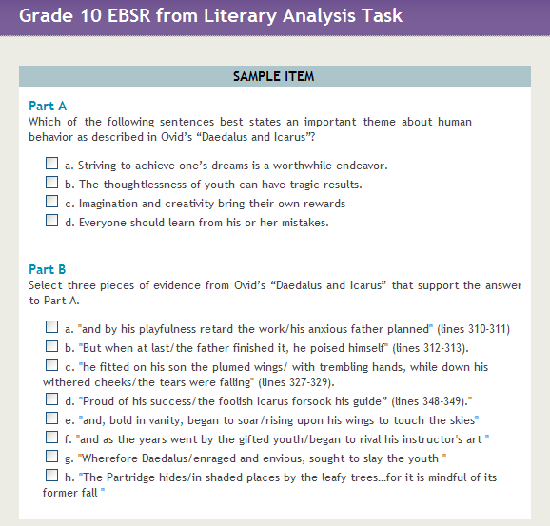

Student Interface Part 2:

Part A below requires students to define Tier 2 academic vocabulary in context while Part B requires students to identify a synonym to both the word “vanity” and “arrogance,” which is the correct answer to Part A.

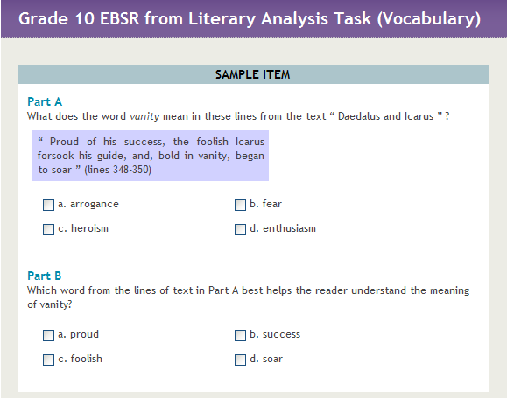

Student Interface Part 3:

The final element of this summative performance task requires students to write a brief expository essay analyzing both pieces of required text. The essay must also adhere to the conventions of Standard English. Students will type their answer in a live text box using standard computer-based word processing tools, which allow students the opportunity to edit their writing before submitted their final product. The word processing tools are also an example of the Universal Design for Learning-aligned elements that are being built into the PARCC assessment system design to accommodate all students.

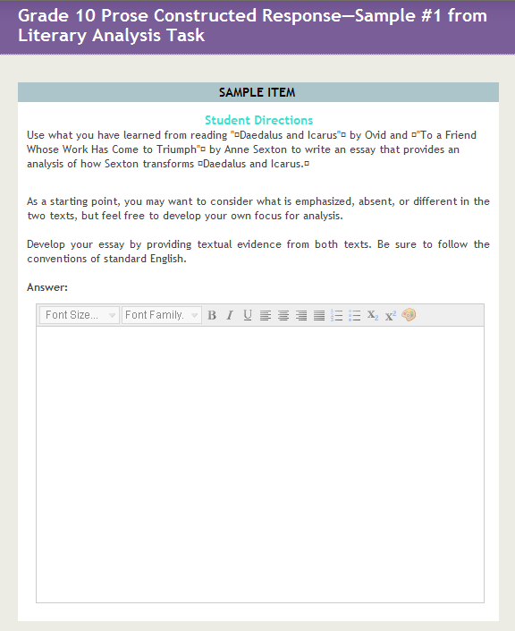
DISCUSSION
After reviewing the prototype assessment task, respond to the following guiding questions:
Guiding Question 1:
What practices are currently in place in your district to support students’ success?

Guiding Question 2:
What shifts in thinking will need to take place to ensure students’ success?

Guiding Question 3:
What shifts in practice will need to take place to ensure students’ success?

